**SMART HALL USING ARDUINO**

**Introduction**

Dictionary defines automatic as a process undertaken with minimal or no human aid. Home automation is a process of revolution involving aspects of mechanical control to be computerized. Era of comfort has brought with itself compulsion of comfort and ambience.

The significance of computer programming is evident in utilisation of electronic devices for human luxury. In energy deficiency times conversation is prime concern, this model helps in conservation of energy by saving electricity when not in use.

Sensor network and one central control section have been used in this project. The network is connected with IR Sensors and relays. Sensors will be in communication with microcontroller. Whenever a person enters into a particular zone, his presence will be detected by Ultrasonic Sensor and it will send this information to controller

Home Automation plays an important role in maintaining these living standards of employed population by providing a secure & convenient environment. Home automation is similar to smart home, digital home, e-home and intelligent household. The system offers users an easy & effective means of controlling their various home appliances from a remote location i.e. without physically being present at home

**Why did we decide we decide to make this project?**

In present scenario, electricity scarcity is the one of the major problem which the people are facing in everyday life. Resources should be used economically to conserve them for future use since they are limited and will expire on one day. So we need to conserve energy daily to conserve our energy. To overcome the situation a system is to be proposed such that the electrical appliances should be turned OFF when not in use. It is difficult for the user to switch OFF the electrical appliances when the switches are located far away from them. So a system is needed to operate the electrical appliances from a distance. All of us need to conserve energy but the great deal is finding out the best ways to conserve energy and save power. Many methods were proposed for this conservation strategy. But here a system is proposed at low-cost to unplug the fans and light when it is not in use.

**Materials and Methods**

Components used:

* Hardware:

|  |  |  |  |
| --- | --- | --- | --- |
| **S. No.** | **Name of Component** | **Picture** | **Description** |
| 1. | Microcontroller | Image result for microcontroller | A **microcontroller** is a small computer on a single integrated circuit. In modern terminology it is similar to a system on a chip. A microcontroller contains one or more CPUs along with memory and programmable input/output peripherals. |
| 2. | IR module | Image result for ir module | **IR sensor** is very popular **sensor** which is used in many applications in electronics, like it is used in Remote control system, motion **detector**, Product counter, Line follower Robots, Alarms etc |
| 3. | LED | Image result for LED |  |
| 4. | Lipo Battery -12 volt | Image result for lipo battery |  |
| 5. | Jumper Wires | Image result for jumper wires |  |
| 6. | Servo Motor | Image result for servo | A servo motor is a Rotary Actuater or linear Actuater that allows for precise control of angular or linear position. It consists of a suitable motor coupled to a sensor for position feedback |
| 7. | Ultrasonic sensor | Image result for ultrasonic sensor | **Ultrasonic sensors** measure distance by using **ultrasonic** waves. An optical **sensor** has a transmitter and receiver, whereas an **ultrasonic sensor** uses a single **ultrasonic** element for both emission and reception |
| 8. | Motors |  |  |

* Software:

1.Arduino IDE (Integrated Development Environment)

The Arduino**integrated development environment (IDE)** is a cross platform  application (for Windows, macOS, Linux) that is written in the programming language Java. It is used to write d upload programs to Arduino board.

The source code for the IDE is released by GNU General public Licence, version 2. The Arduino IDE supplies software library from the Wiring project, which provides many common input and output procedures.

2. Fritzing :

Fritzing is an open source hardware initiative that makes electronics accessible as a creative material for anyone. It is a software tool and a community website for processing and Arduino ,fostering a creative ecosystem that allows users to document their prototypes, share them with others ,teach electronics in classroom, and layout and manufacture professional pcbs.

Method:

Circuit Designing:

Step 1: A wall is used and it is connected to two ultrasonic sensor. As the person will enter the hall , lights, fans will get switched on and as he will go out , the they will get off.

Step 2: Distance is measured which gives the idea of a person coming.

Step 4: 2 ultrasonic sensors are used.

Ultrasonic sensor 1 : ECHO is connected to 2nd terminal of Arduino and TRIGGER is connected to 3rd.

Ultrasonic sensor 2 : ECHO is connected to 4th terminal of Arduino and TRIGGER is connected to 5th.

Step 3:Ground and VCC are used.

Step 4:2 LED’s are used . 1 is connected to 9th terminal of Arduino and 2nd is connected to 10th terminal of Arduino.

Step 5:Motors are connected to 10th and 11th terminals of Arduino.

Software :

Step 1: Fritzing

Step 2:Upload into Arduino IDE.

**Schematics**

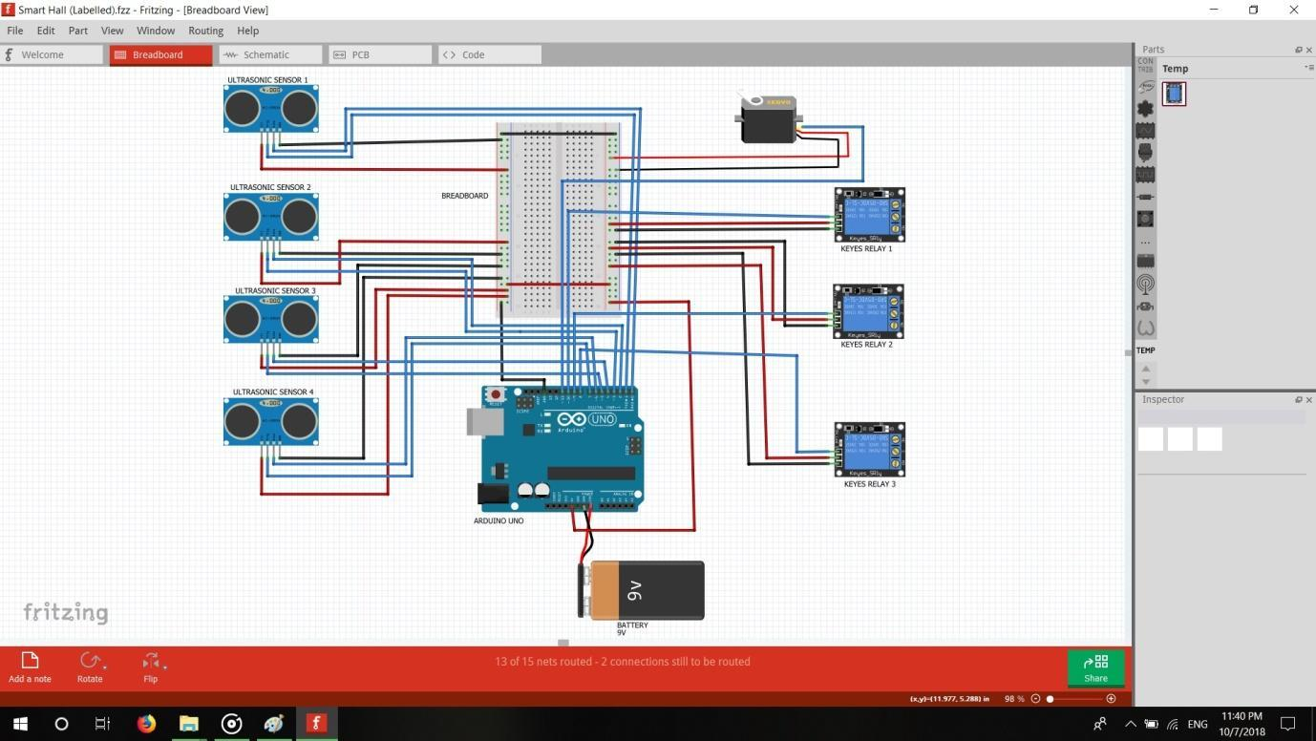

**Cad Model**

**Future scope**

1. In the design proposed above we have implemented a Wireless home automation control system using Arduino Uno microcontroller which is very simple and feasible to use. The safety of user is considered and hence wiring the devices with server is done with utmost care.

2.Electrical appliances like fans and lights has been automatically operated using Bluetooth module according to the data sent by the mobile to Arduino through the Bluetooth interface. Thus, we can save the energy and electricity.

3. In real time web based home automation system this project can be extended in future to ensure the high security. With this, the system can be incorporated in a whole building of any institution or residential building and can monitor from anywhere.

4. Sensors like motions sensor, temperature sensors, light intensity sensors, smoke detectors and humidity sensors are being accommodated with home automation system.

5. The home automation market is undergoing a technological shift so as to cope with energy wastage and greenhouse emissions caused by improper handling and utilization of resources in the residential marketplace.